BSG Craft Sana beta site testing

Issues found:

1. If you order a pallet of an item and Qty of that same item, the pallet order gets overwritten by the qty. screenshot below

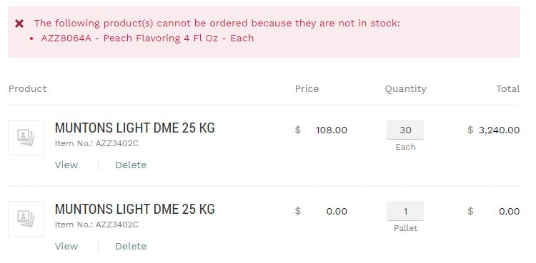

1. When you add items to cart and “request a quote” your shopping cart is now empty. You have to individually put the items back to cart if you don’t accept the quote. Maybe on purpose? Seems like small issue though since user can edit the quote and order it right away from quote page

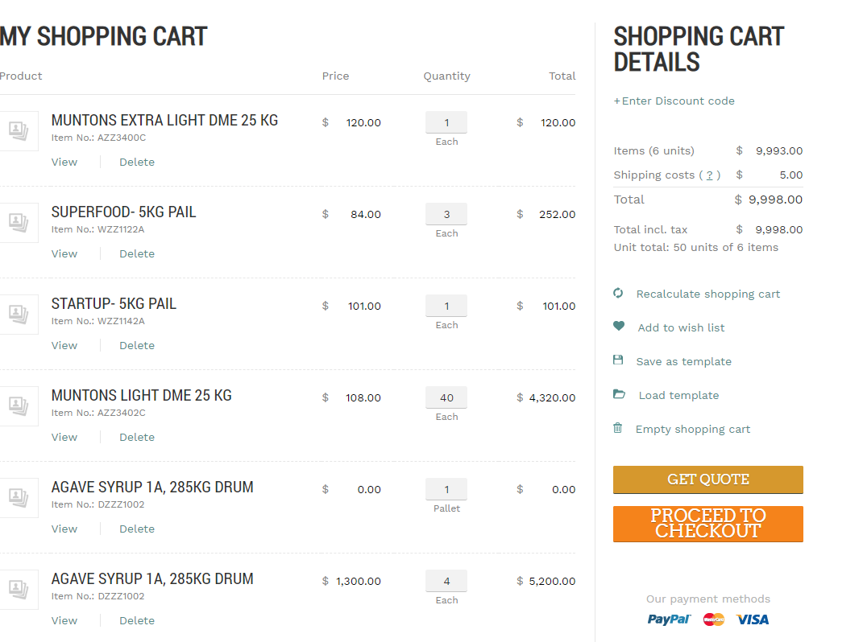

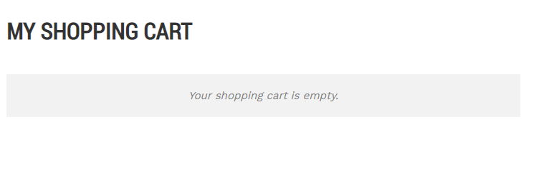

1. The wording in shopping cart details is confusing. As you can see below, I have 5 different SKUs with total of 15 qty, on the right we see it says items (5 units) meaning “units” in here means SKUs, but in “unit total” it says 15 units of 5 items. This means here “units” means QTY. seems like it could cause confusion.

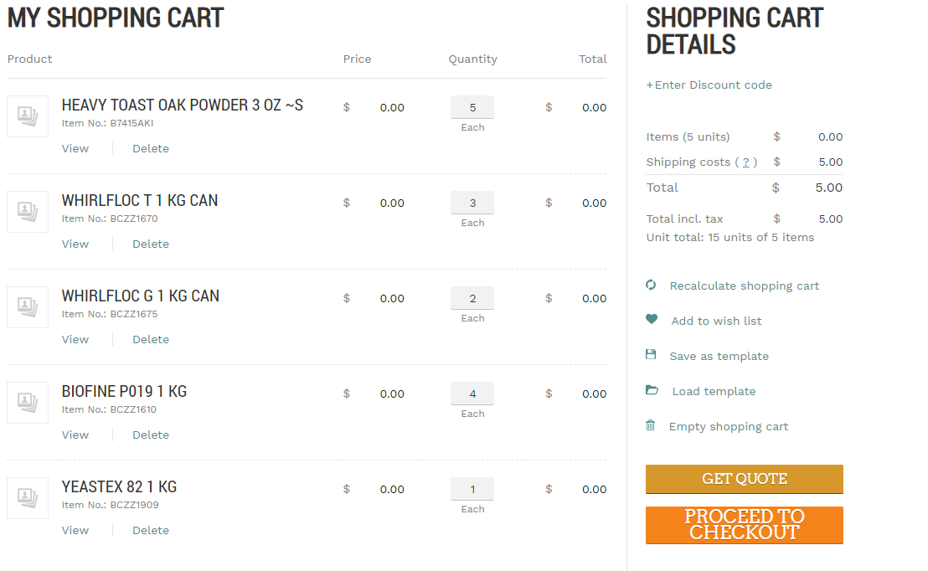

1. Items availability changed when different user adds item into cart, even though that customer haven’t completed the purchase yet. For example I’m currently representing summit

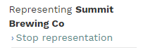

I then, add all available qty of an item to my cart

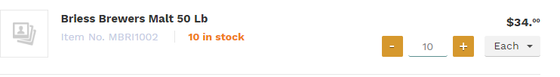

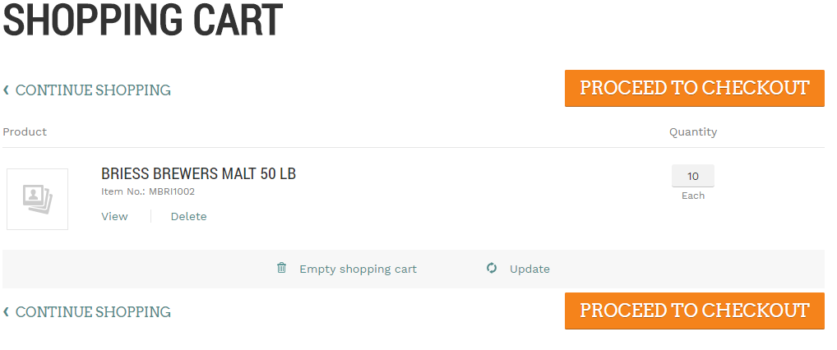

Now I login as different customer

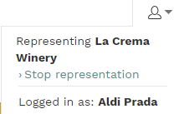

And that same item is marked as out of stock even though as Summit Brewing, I never actually bought those items, just added them to cart

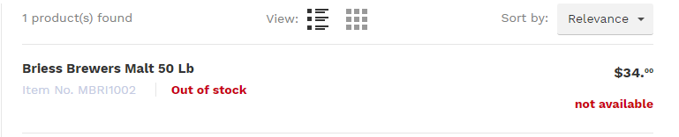

Hypothetically, someone could maliciously add every item in the website to their shopping cart and the entire website will show up as sold out for everyone else and no one can place order. Nate mentioned maybe qty will be hidden and that there will be max qty limit allowed to prevent this. It’s possible this is also only a beta issue since real customer won’t have the ability to switch out to multiple accounts, but it’s something we should keep in mind